Mark Kardash

Professor Walther Del Orbe

CMIS 242: Intermediate Programming

14 September 2022

CMIS 242 Assignment 2 Test Cases:

|  |  |  |  |  |
| --- | --- | --- | --- | --- |
| Test # | Input Values | Expected Result | Actual Result | Pass/Fail |
| Test 1 | Enter your selection: 2 | “Thank you for using this program! Goodbye!” | “Thank you for using our program! Goodbye!” | Pass |

Test 1 Screenshot:

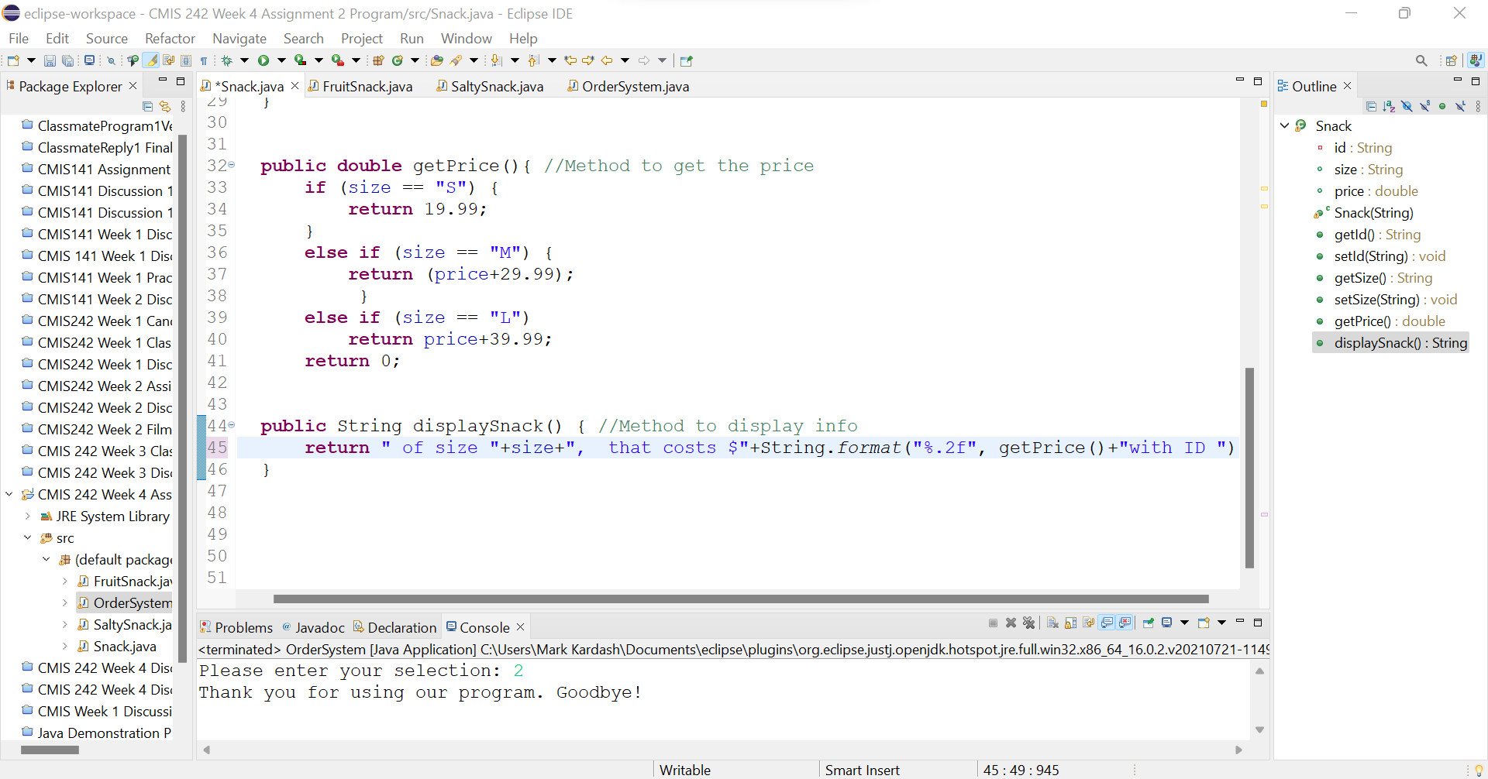

|  |  |  |  |  |
| --- | --- | --- | --- | --- |
| Test # | Input Values | Expected Result | Actual Result | Pass/Fail |
| Test 2 | Enter your selection: 1  Do you want Fruit Snack (1) or Salty Snack (2): 1  What size would you like? S, M, or L: M  Should we include citrus fruit? True or False: True | “You have chosen a Fruit Snack of size M, that costs $45.98, with ID RE7732” | Nothing Displayed. | Fail |

Test 2 Screenshot:

|  |  |  |  |  |
| --- | --- | --- | --- | --- |
| Test # | Input Values | Expected Result | Actual Result | Pass/Fail |
| Test 3 | Enter your selection: 1  Do you want Fruit Snack (1) or Salty Snack (2): 2  What size would you like? S, M, or L: L  Should we include a nut snack? True or False: False | “You have chosen a salty snack of size L, that costs $49.99, with ID RE7105” | Nothing Displayed. | Fail |

Test 3 Screenshot:

